AoR Microgrant SAMPLE Application

ELIGIBILITY QUESTIONS:

I am a:
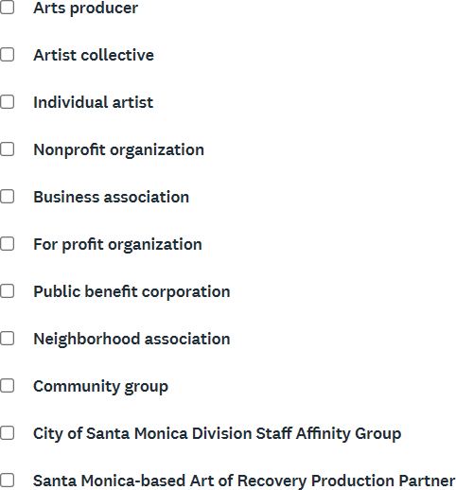

Will your program take place entirely within the City of Santa Monica?

Will your program be actively promoted to Santa Monica residents, workers, and visitors?

Will your project take place in, or be viewable from, public spaces within Santa Monica, and will it be open to the public?

Does your project enliven public spaces and produce new artworks or events that strengthen and connect Santa Monicans?

Will your project offer free or low-cost tickets?
CONTACT INFORMATION

First Name:

Last Name:

Company/Entity Name:

City:

Zip Code:

Phone Number:

Website:
Social Media:

APPLICATION QUESTIONS

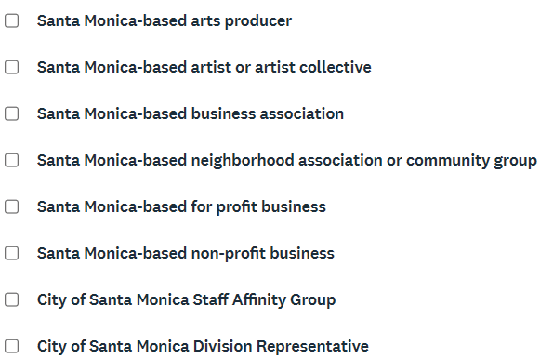
I am a:

Project Name
Provide a brief description of your proposed AoR Microgrant Project.

Tell us about your project. Is it a new initiative or a work in progress?

How will AoR Microgrant funds specifically support this project (e.g., materials, space, collaborators, outreach)?

Start your response with “AoR Microgrant funding will support…”

Santa Monica / Community Engagement

Is there a particular location, site, or neighborhood in Santa Monica where this project will take place (for example, a specific park, library, school, or neighborhood festival)?

Please also describe how your project will connect with or be experienced by the Santa Monica community.

Please note the date and timeframe of the event.

WORK SAMPLES

To help evaluate your artistic and cultural programming, please submit 2 recent samples (from the past 3 years) that convey the quality of your work and/or proposed project.

Video Samples: Limit each video to 5 minutes. Provide links via YouTube or Vimeo.Image Samples: Limit each sample to a maximum of 10 images. Submit as a PowerPoint or PDF file.

Sample 1

Upload Attachment or Insert Link in the next question below (Preferred)

Description: | (No response)
Title: | (No response)
Link: | (No response)

Sample 2

Upload Attachment or Insert Link in the next question below (Preferred)

Description: | (No response)
Title: | (No response)
Link: | (No response)

BUDGET DETAILS

Please identify your requested grant amount to support artistic fees and other expenses for your project. Award amounts are $500 to $5,000.
Project Budget:

 | Expenses ($)
Artist fees
Rentals
Staffing
Marketing
Other
Total | 0

While no cash match is required, does your project leverage additional funding sources?

Will your project charge for tickets or admission fees?

If yes, please describe your pricing structure, including any efforts to ensure affordability and access (e.g., sliding scale, discounts, free tickets for specific audiences, etc.).

